**Lab Report**

Title: Lab 0

Notice: Dr. Bryan Runck

Author: Ethan Bott

Date: 9/20/22

**Project Repository:** [**https://github.com/swimbott/GIS5571**](https://github.com/swimbott/GIS5571)

**Time Spent:** 12 hours

**Abstract**

The ArcGIS lessons were completed taking me from the basics of GIS all the way to notebooks, arcpy and ArcGIS Online.

Five folders for the 5 labs were created committed into the repo for this class.

Three maps were made of forest service roads in Atkin County, MN. A 30 foot buffer was created for the roads in ArcPro, in Arcpy and finally through notebooks through ArcGIS Online.

**Problem Statement**

The Esri ecosystem has numerous ways that you can access the same underlying functionality. The objective is to compare and contrast performing the same simple activity - buffer a network dataset - using three different tools: ArcPro, Jupyter Notebooks in ArcPro, Jupyter Notebooks in ArcOnline. This lab will complete the ArcGIS online tutorials, become familiar with Github and create the appropriate folders in your repo, and create three road maps with some type of buffer using three different methods.

*Table 1. Road data inputs*

|  |  |  |  |  |  |  |
| --- | --- | --- | --- | --- | --- | --- |
| **#** | **Requirement** | **Defined As** | **(Spatial) Data** | **Attribute Data** | **Dataset** | **Preparation** |
| 1 | Road network | Raw input dataset from Aitkin County GIS | Road geometry |  | [Mn GeoSpatial Commons](https://gisdata.mn.gov/dataset/trans-roads-mndot-tis) |  |

**Input Data**

The forest service data came from the Aitkin County GIS department for the intention of having accurate forest roads for forest management activities. This was downloaded from the MN GeoSpatial Commons. This data was collected from 1999-2000.

*Table 2. Road data metadata and source*

|  |  |  |  |
| --- | --- | --- | --- |
| **#** | **Title** | **Purpose in Analysis** | **Link to Source** |
| 1 | Aitkin County Land Dept. Forest Roads, Aitkin County | Raw input dataset for buffer analysis from Aitkin County GIS | [Mn GeoSpatial Commons](https://gisdata.mn.gov/dataset/us-mn-co-aitkin-trans-forest-roads) |

**Methods**

The Aitkin County Forest Road data was brought into ArcPro. Using the buffer tool (Figure 1), the forest road data was placed as an input and the output was titled using a 30 foot buffer. After running the tool, this created a 30 foot buffer around all Aitkin County Forest Roads.

*Figure 1. Data flow diagram.*

This was done in Juypter Notebooks in ArcPro as well using code (Figure 2). The resulting map had a different name with ArcPy in it to differentiate it from the other ArcPro buffer.

*Figure 2. Arcpy Code*

import arcpy

arcpy.analysis.Buffer("forest_roads",r"C:\Users\swimb\Documents\UMN\fall2022\GIS5571\lab0\Lab0\Lab0.gdb\forest_tests_buffer_30ft_arcpy", "30 Feet", "FULL", "ROUND", "ALL", None, "PLANAR")

The final method was done in notebooks on ArcGIS Online. The data was imported into ArcGIS Online as a zipped file into contents. Then it was brought into the notebook. A map of Aitkin County was brought up to make sure the roads came in clearly which they did. Then a road buffer script (Figure 3) was written to put a 30 foot buffer around the roads. And finally, it produced a simple map of 30 foot road buffers around the forest service roads in Aitkin County.

*Figure 3. Notebooks on ArcGIS Online Code*

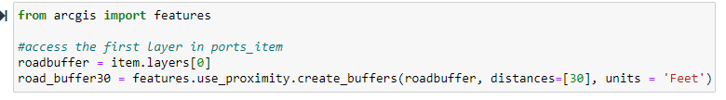

**Results**

The analysis successfully worked, creating 30 foot buffers around the forest service roads in Aitkin County. A zoomed in map was shared to show the 30 foot buffer along the forest road centerline. A picture of just the service roads is provided as well as the 30 foot buffers. For the ArcPro and Arcpy methods, it produced identical results as seen in (Figure 5). The final map ((Figure 6) shows a how the map looked when done in notebooks on ArcGIS Online. The same result, but just slighting different symbology.

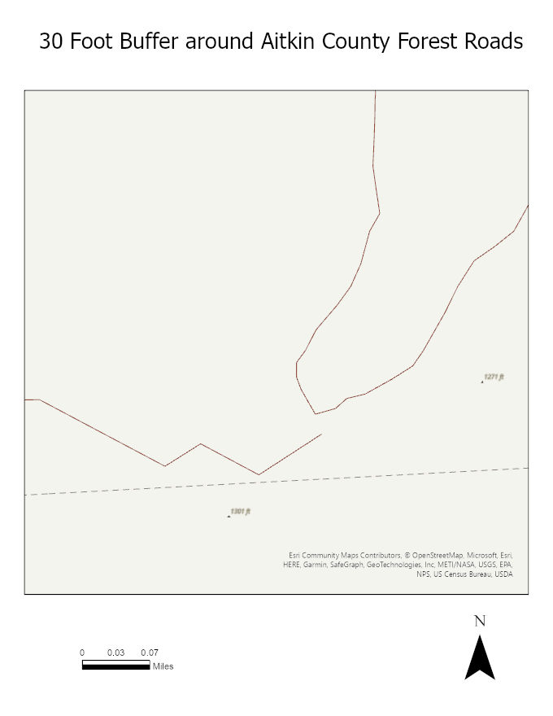

**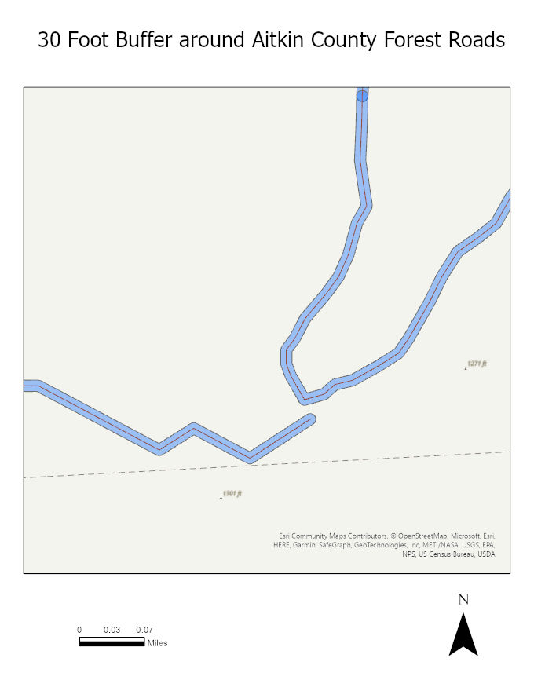***Figure 4. Forest Service Roads Figure 5. 30 Foot Buffers on Forest Roads*

*Figure 6. 30 Foot Buffers on Forest Roads*

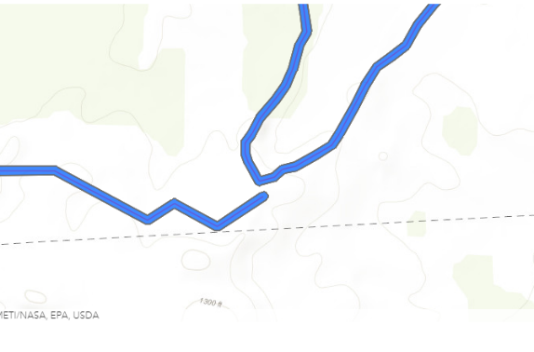

**Results Verification**

I know the results of the three buffer methods are the same since my inputs were exactly the same. The units and length of unit were the same when entered either through code or through the ArcPro interface. I also measured the buffer width from the center line to the edge of the buffer and they were all 30 foot buffers.

**Discussion and Conclusion**

Github

I use Github with my work place and so I am quite familiar with version control systems and such. However this was the first time I added folders on github rather then through the file explorer so that was fun to add folders and commit those changes on github. Everything else was pretty standard with creating a repo and committing changes.

For the ESRI trainings, I had my first intro to the notebooks, Arcpy, and several ArcGIS Online functions. They were very solid trainings to give a refresher in all things GIS.

For the three buffer methods, the ArcPro way took just a few minutes. The Arcpy method I had not done before, but was relatively intuitive as the documentation was right there when looking at the history of the previous tool. I had a couple of challenges with the notebooks on ArcGIS Online where one of them was just figuring out where to start. But after looking at some previous examples of notebooks online and reading some documentation on buffers on the ArcGIS API site, I was able to write successfully scripts to get the buffer to run.

**Self-score**

|  |  |  |  |
| --- | --- | --- | --- |
| **Category** | **Description** | **Points Possible** | **Score** |
| **Structural Elements** | All elements of a lab report are included **(2 points each)**:  Title, Notice: Dr. Bryan Runck, Author, Project Repository, Date, Abstract, Problem Statement, Input Data w/ tables, Methods w/ Data, Flow Diagrams, Results, Results Verification, Discussion and Conclusion, References in common format, Self-score | 28 | **28** |
| **Clarity of Content** | Each element above is executed at a professional level so that someone can understand the goal, data, methods, results, and their validity and implications in a 5 minute reading at a cursory-level, and in a 30 minute meeting at a deep level **(12 points)**. There is a clear connection from data to results to discussion and conclusion **(12 points)**. | 24 | **24** |
| **Reproducibility** | Results are completely reproducible by someone with basic GIS training. There is no ambiguity in data flow or rationale for data operations. Every step is documented and justified. | 28 | **28** |
| **Verification** | Results are correct in that they have been verified in comparison to some standard. The standard is clearly stated **(10 points)**, the method of comparison is clearly stated **(5 points)**, and the result of verification is clearly stated **(5 points)**. | 20 | **20** |
|  |  | 100 | **100** |